Chatham University Music Department:
Friday Afternoon Musicale
Bach, Debussy, Beethoven

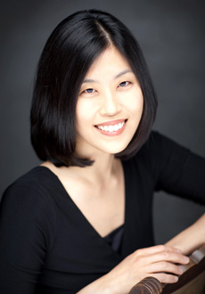

Shirley Yoo, piano

November 14, 4:00 p.m.
James Laughlin Music Hall

